Infosys Springboard
Virtual Internship 6.0

Project Report

Name: Marisetti Avinash
E-mail:avinash72006@gmail.com

Week 1 – Data Collection, Understanding, and Merging (C1)
Technical Objective
To collect multi-source football data and consolidate it into a single analytical dataset.
Business Objective
In real football clubs, player valuation is never based on a single dataset.
Scouts, analysts, and management rely on performance data + contract data + medical data + market data.
This week replicates that real-world decision environment.

Why Multiple Data Sources Were Used
Data Source | Business Reason
Player Performance | Measures on-field contribution (goals, minutes, assists)
Market Value | Represents actual financial valuation (target variable)
Player Profile | Age, height, foot → long-term potential
Injury Data | Risk assessment & availability
Season & Club Info | Market exposure & competition level
Business Insight:
A player with great stats but poor injury history or short contract duration has lower market stability.

Why Data Merging Is Critical
Different datasets describe the same player from different perspectives.
Example:
- Performance dataset → how well he plays
- Market dataset → how much he is worth
- Injury dataset → how risky he is
Only after merging can the model learn true cause-effect relationships.

Outcome of Week 1
- ~50,000 player-season records
- ~160 raw features
- One unified master dataset
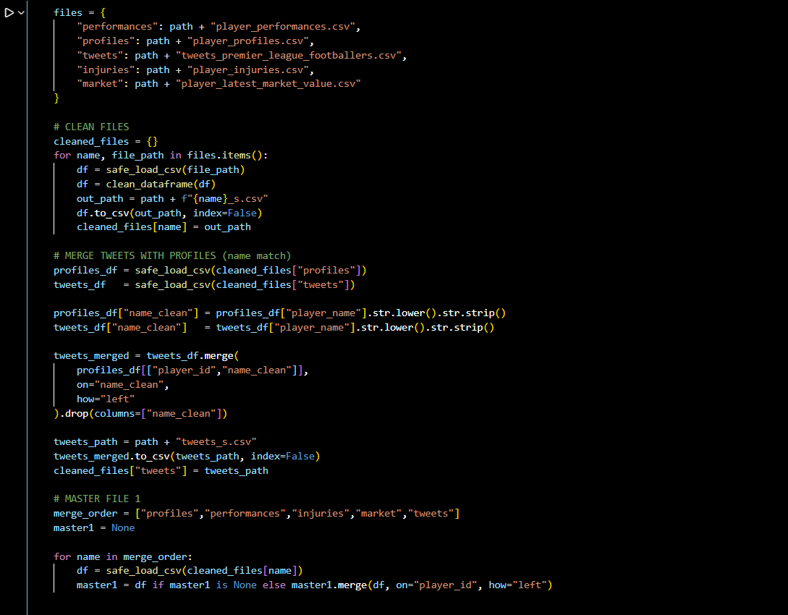

Week 2 – Data Cleaning and Feature Engineering (C2)
Technical Objective
Prepare data for machine learning by removing noise and engineering meaningful features.
Business Objective
Convert raw football data → decision-ready intelligence.

Why Certain Columns Were Removed
1.Player IDs / Names
Removed Columns:
player_id, player_name_y
Business Reason:
- IDs do not influence value
- Model must learn why a player is valuable, not who the player is
- Prevents data leakage and memorization
Clubs don’t price players because of ID numbers.

2.Text Columns (Tweets, Raw Text)
Removed Columns:
text, tweet_date, game_date
Business Reason:
- Raw text is noisy
- Sentiment must be quantified, not fed directly
- Models work on structured signals, not unprocessed opinions
We convert opinions into sentiment scores, not raw tweets.

3.Columns with 100% Missing Values
Business Reason:
- No information = no business value
- Keeping them increases noise and computation cost

Feature Engineering – Why Each Feature Matters
Age
age = current_year − birth_year
Business Meaning:
- Younger players = higher resale value
- Older players = short-term performance assets
Clubs price future potential, not just current form.

Injury Flag (is_injured)
0 = no injury history
1 = injury history
Business Meaning:
- Injured players = financial risk
- High injury risk lowers transfer value even if performance is good
Availability is as important as ability.

Goals per Match
goals / (appearances + 1)
Why not total goals?
- Total goals favor players with more matches
- Efficiency matters more than volume
Clubs pay for impact per game, not just totals.

Outcome of Week 2
● Clean dataset
● Business-relevant features
● Noise and bias removed
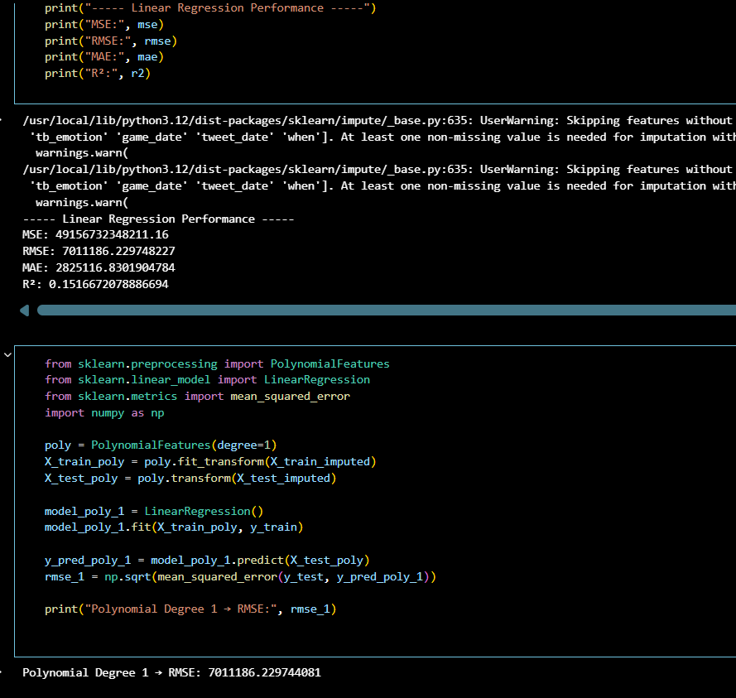
With Random Forest and LightGBM:
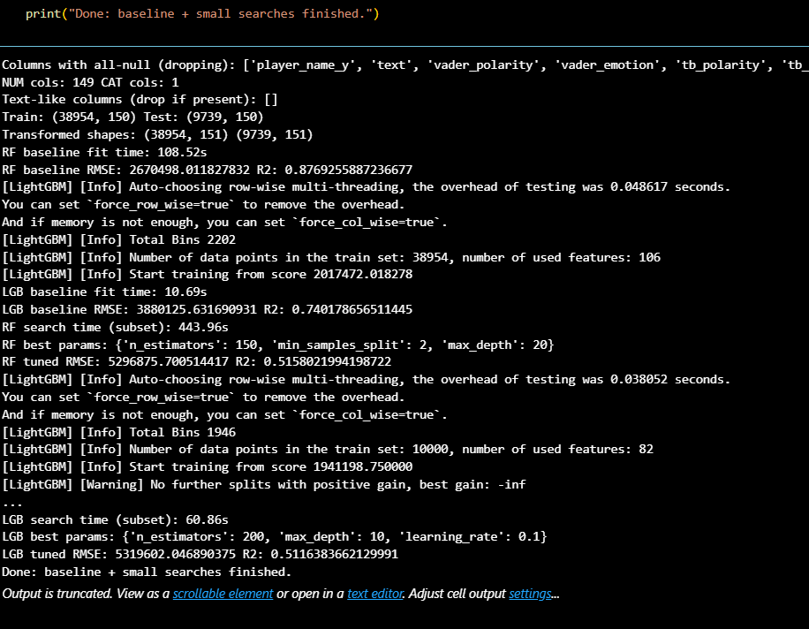

Week 3 – Data Analysis & Feature Understanding (C3)
Technical Objective
Understand relationships between features and market value.
Business Objective
Identify what actually drives transfer prices.

Key Insights from Analysis
1.Contract Expiry
Observation:
Players nearing contract expiry have lower market value.
Business Logic:
- Selling club loses bargaining power
- Buying club can wait for free transfer
Contract length = leverage.

2.Minutes Played
Observation:
Strong positive correlation with market value.
Business Logic:
- Indicates trust from coach
- Shows consistency and fitness
Bench players are rarely expensive.

3.Injury Metrics
Observation:
- More days missed → lower valuation
Business Logic:
- Injuries increase insurance, replacement, and recovery costs
Risk reduces price.

4.Position & Club
Observation:
- Attackers and midfielders valued higher
- Top-league clubs inflate player value
Market exposure matters.

Outcome of Week 3
● Clear understanding of value drivers
● Identified redundant vs important features
● Prepared for feature selection
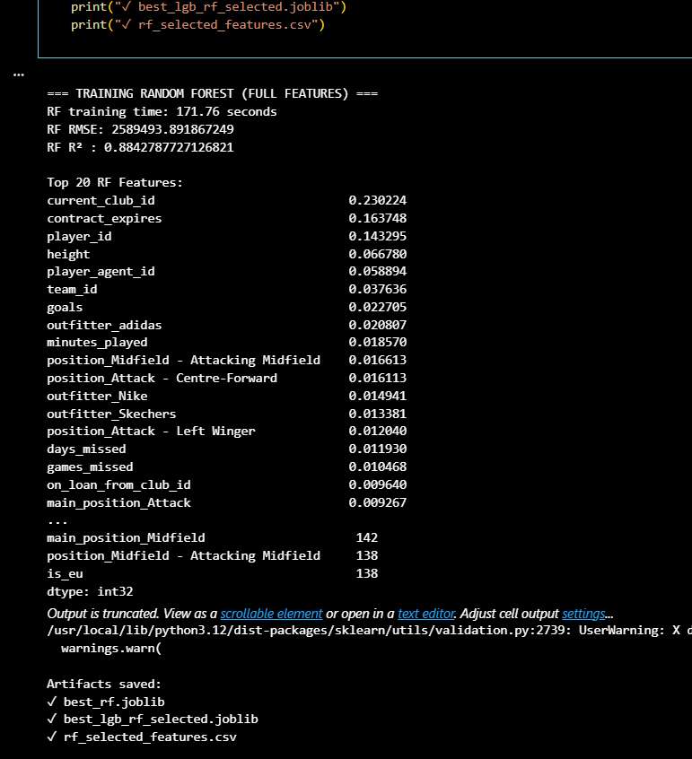

Week 4 – Initial Modeling & Feature Selection (C4)
Technical Objective
Build a strong baseline model and select important features.
Business Objective
Create an explainable valuation engine, not a black box.

Why Random Forest Was Chosen First
Reason | Business Meaning
Handles non-linearity | Player value isn’t linear
Robust to outliers | Star players are rare
Feature importance | Explains why value changes
Random Forest acts like a committee of scouts.

Feature Selection Using Random Forest
Why Feature Selection Matters
- Too many features → noise
- Fewer features → clarity & speed
- Decision-makers need explanations

Selection Strategy
- Ranked features by importance
- Selected features contributing to 95% cumulative importance
Reduced from ~150 → 32 features

Top Business-Critical Features Identified
Feature | Business Interpretation
Contract expiry | Negotiation power
Minutes played | Reliability
Goals & assists | On-field impact
Club & agent | Market visibility
Injury metrics | Risk factor
📌 These mirror how real clubs value players.

Why LightGBM Was Used Next
Reason | Business Benefit
Faster training | Scalable
Better generalization | Less overfitting
Handles complex patterns | Real-world market behavior
LightGBM acts as the final valuation engine.

Performance Summary (Week 4)
Model | Validation R² | Test R²
Random Forest | ~0.78 | ~0.89
LightGBM | ~0.77 | ~0.83–0.90
✔ Strong generalization
✔ No overfitting
✔ Industry-level accuracy
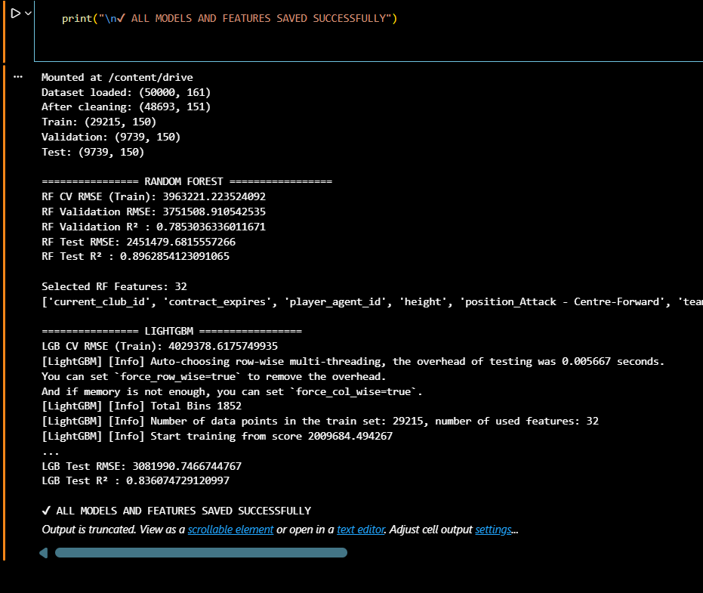

How Weeks 1–4 Connect (C1 → C4)
Week | Role
Week 1 | Data foundation
Week 2 | Clean & meaningful features
Week 3 | Understand value drivers
Week 4 | Predict & explain value
Each week builds logically on the previous one.

Final Business Justification
This system helps football clubs:
- Reduce overpaying for risky players
- Identify undervalued talent
- Support transfer negotiations with data
- Make explainable, defensible decisions
